DWH Offering Analysis

Name: Omer Abid

Erp: 14922

Chosen Topic: AWS: <https://aws.amazon.com/redshift/>

Site used for help: <https://docs.aws.amazon.com/redshift/latest/dg/c_high_level_system_architecture.html>

1) How are they doing dwh (star schema, other formats etc.?)  
2) Is some level of BI integrated within this tool? If yes, what are the features of this BI offering?

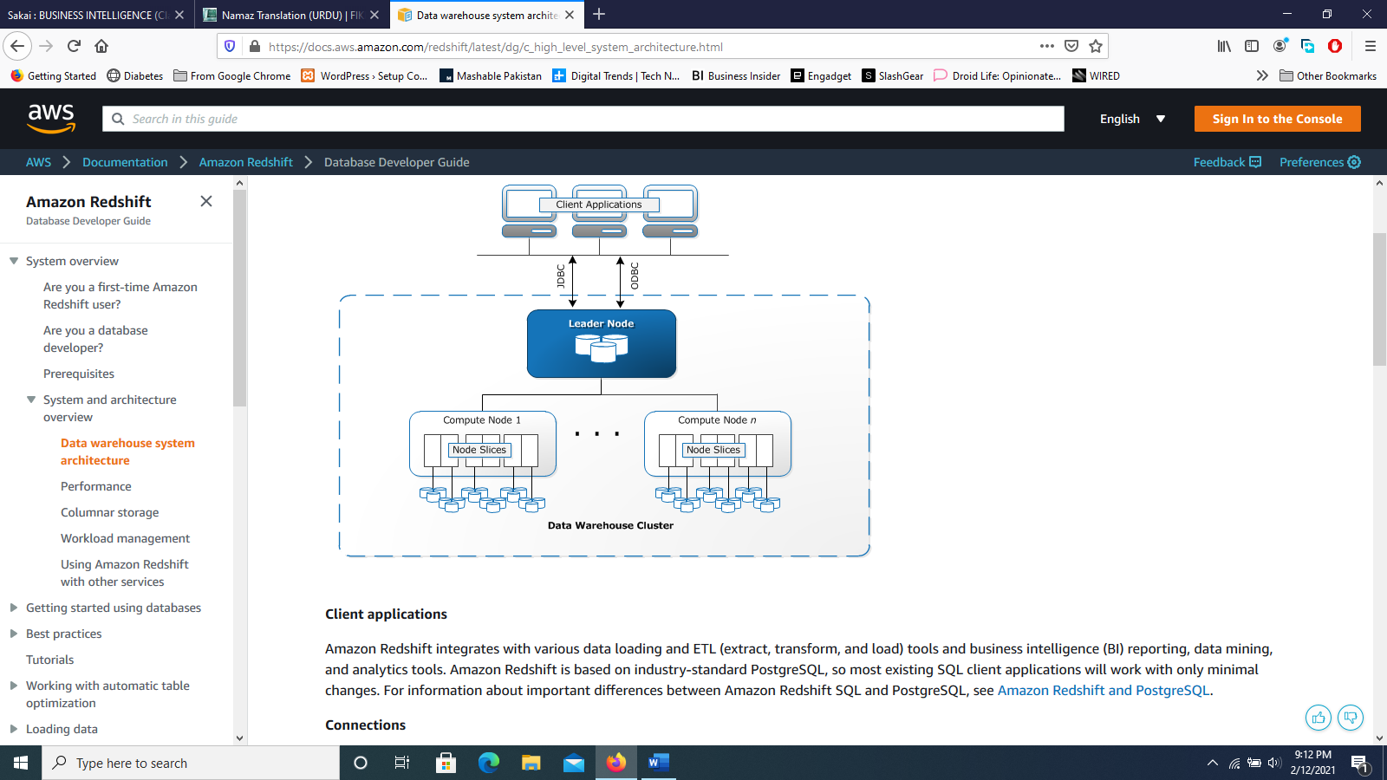Ans (1):

Amazon redshift Datawarehouse basically works based on a cluster. Each cluster have one or more compute nodes. There may be 2 or more compute nodes in a cluster and in this case a leader node is present to manage these compute nodes and works as an interface to the client applications and compute nodes. The client applications are basically SQL client applications and other applications like BI reporting, data mining and much more, which communicate with the leader node and then the leader node works on to the process of executing queries. The leader node basically generates execution plans to carry out database operations to solve complex queries and based on this it compiles the codes to run on the compute nodes and distribute these on to the respective compute node along with respective data portions.

The compute node basically runs the code and pass the results for aggregation to the leader nodes. These nodes have the user data stores on them. Each compute node has its own resources such as memory, CPU, disk storage etc. depending on the node type. As your needs scale you can either add more nodes to the system or even upgrade nodes or do both.

Slicing in compute nodes add parallelism in executing the code. Here the nodes are portioned into slices and each slice processes a portion of the work. The leader node is responsible to distribute data and workload to slices.

A cluster may contain one or more databases and amazon redshift is a rdbms, so it provides features of OLTP.

Ans (2) : Within this tool there is no BI integrated by itself. Although, you could integrate external BI tools like power BI, Tableau, and many other third-party tools.